Path Sum (LeetCode 112)

*Description:*

Given a binary tree and a sum, determine if the tree has a root - to - leaf path such that adding up all the values along the path equals the given sum.

*For example:*

Given the below Binary Tree and sum = 22:

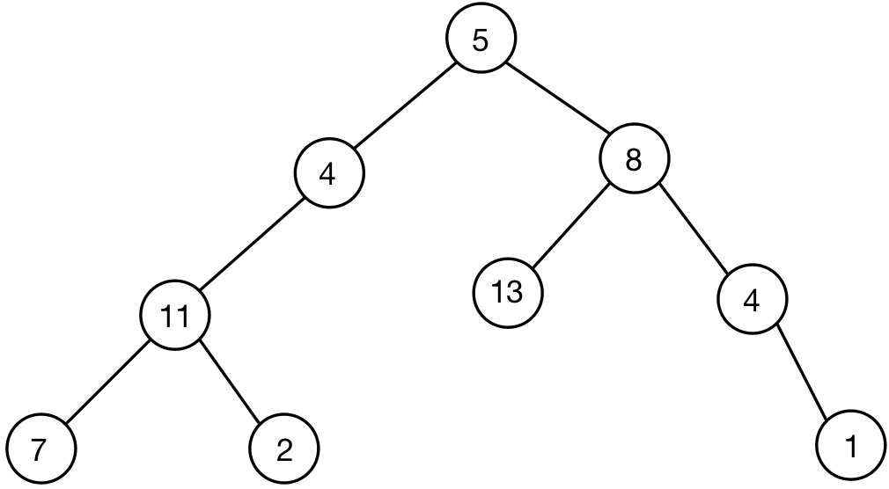

*Analysis from the code, at first process the root node, then process the left node, at last process the right node.*

*/\*\**

*\* Definition for a binary tree node.*

*\* struct TreeNode {*

*\*     int val;*

*\*     TreeNode *left;*

*\*     TreeNode *right;*

*\*     TreeNode(int x) : val(x), left(NULL), right(NULL) {}*

*\* };*

*\*/*

*class Solution {*

*public:*

*bool hasPathSum ( TreeNode* root, int sum ) {*

*if ( root == NULL )*

*return false;*

*int sum_left = sum - root->val;*

*if ( root->left == NULL*

*&& root->right == NULL*

*&& sum_left == 0 )*

*return true;*

*bool left = hasPathSum ( root->left, sum_left );*

*bool right = hasPathSum ( root->right, sum_left );*

*return left || right;*

*}*

*};*